**ARYAMAN MISHRA**

**19BCE1027**

**CSE4001 - L15+16**

**Usage of firstprivate**

#include<stdio.h>

#include<omp.h>

int main(void)

{

int i=10;

#pragma omp parallel firstprivate(i)

{

i=10+omp_get_thread_num();

printf("thread %d:i=%d\n",omp_get_thread_num(),i);

}

return 0;

}

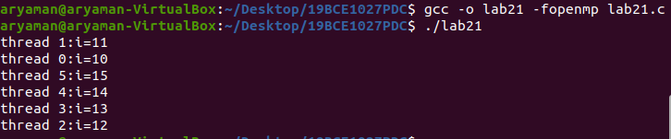

**Adding two arrays**

#include <omp.h>

#include <stdio.h>

int main()

{

int a[10],b[10],i,sum[10];

for (i=0; i<10; i++)

{

printf("Input in a[%d]: ",i);

scanf("%d",&a[i]);

}

for (i=0; i<10; i++)

{

printf("Input in b[%d]: ",i);

scanf("%d",&b[i]);

}

#pragma omp parallel for

for (i=0; i < 10; i++)

{

sum[i] = a[i] + b[i];

printf("CPU:%d\tThread:%d\tValue:%d\n",sched_getcpu(),omp_get_thread_num(),sum[i]);

}

}

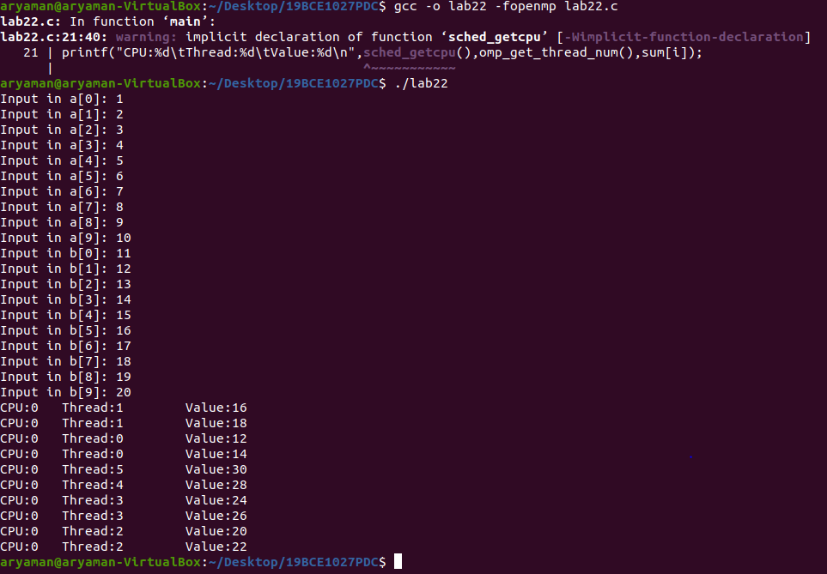

**Addition of factors of a number**

#include<omp.h>

#include<stdio.h>

#include<stdlib.h>

int main()

{

int n,m,i,j;

printf("Enter number of factors.\n");

scanf("%d",&n);

printf("Enter a number.\n");

scanf("%d",&m);

int a[n];

for(i=0;i<n;i++)

{

a[i]=i+1;

}

int sum=0;

#pragma omp parallel for firstprivate(sum)

for(i=2;i<m+2;i++)

{

for(j=0;j<n;j++)

{

if(a[j]%i==0)

{

sum=sum+a[j];

}

}

printf("cpu: %d\tthread: %d\tnumber: %d\tsum: %d\n",sched_getcpu(),omp_get_thread_num(),i,sum);

sum=0;

}

}

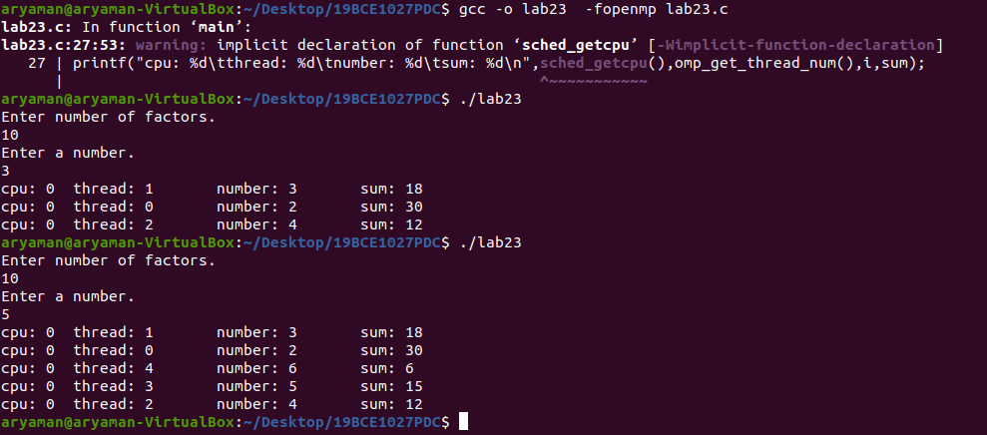

**Addition of odd and even numbers**

#include <omp.h>

#include <stdio.h>

int main()

{

int n,i,sum_even=0,sum_odd=0;

printf("Enter numbers.\n");

scanf("%d",&n);

int a[n];

printf("Enter numbers in array.First odd then even or enter in whichever order.\n");

for (i=0; i<n; i++)

{

printf("Input in a[%d]: ",i);

scanf("%d",&a[i]);

}

#pragma omp parallel for

for (i=0; i < n; i++)

{

if (a[i] % 2 == 0)

sum_even += a[i];

if(i==n-1)

printf("CPU:%d\tThread:%d\tValue:%d\n",sched_getcpu(),omp_get_thread_num(),sum_even);

}

#pragma omp parallel for

for (i=0; i < n; i++)

{

if (a[i] % 2 != 0)

sum_odd+= a[i];

if(i==n-1) printf("CPU:%d\tThread:%d\tValue:%d\n",sched_getcpu(),omp_get_thread_num(),sum_odd);

}

}

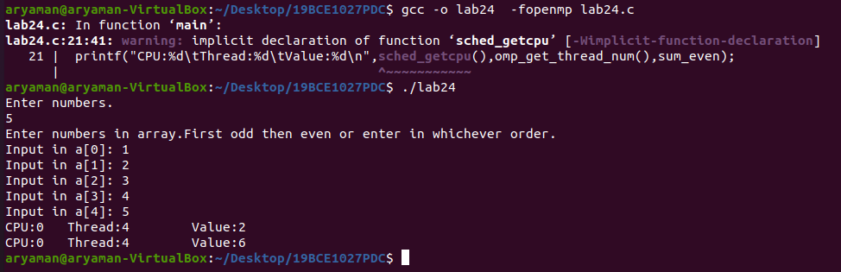

**RESULT:ALL 4 PROGRAMS HAVE BEEN SUCCESFULLY COMPILED AND EXECUTED.**